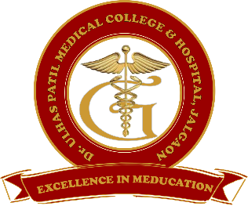**Godavari Foundation’s**

**DR. ULHAS PATIL MEDICAL COLLEGE & HOSPITAL,**

**Recognized by Medical Council of India, Approved by Central Govt. of India, New Delhi,**

**Letter no. MCI-34(41)/2012-med./158127, dated 05/02/2013**

**Affiliated to Maharashtra University of Health Sciences, Nashik [College Code-1306]**

**Jalgaon-Bhusawal Road, NH-6, Jalgaon Kh, Tal. & Dist. Jalgaon 425309**

**Tel. No. (0257)2366657, 2366678 Fax No. 0257-2366648**

**Email ID :** [**dupmcj@yahoo.in**](mailto:dupmcj@yahoo.in) **Web Site :** [**www.dupmc.ac.in**](http://www.dupmc.ac.in)

**5.3.2 Presence of a Student Council, its activities related to student welfare and student representation in academic & administrative bodies/ committees of the Institution**

Student council at Dr. Ulhas Patil Medical College & Hospital Jalgaon Kh. provides various kinds of Academic and Administrative inputs during various events. The students council is formed each year and nominated students are choosen as per guidelines prescribed by MUHS, Nashik.

The student council is headed by the college Dean. Other members constituting the council are One Teacher, Sports Director, Officer in charge of cultural activities, One student from each class from 2nd year to final year, one Intern, One student having outstanding performance in each category like Sports, Cultural and Research, two female students having outstanding performance in sports, cultural or research work, and a student secretary.

**OBJECTIVES ARE:**

* To be a representative body acting as a bridge between Administration and students
* To make administration aware about problems faced by students, and make students aware regarding any concerns the Administration has
* To be the voice of students in Academic, and extracurricular matters
* To inculcate leadership and team spirit in students
* Organize capability enhancement programs
* Control and preside over various student committees
* to counsel, provide support, and advice to problems faced by students and overcome their problems

Following is the summary of various activities conducted by the student council during the past five years

* Organizing orientation program
* Organizing various sports competitions
* Organizing various cultural competitions
* Celebrating various Indian festival
* Assisting the faculties during the mentorship activities
* Celebrating the various special days and events and commemorative days
* Participating and Assisting the faculties for the activities of the important committees like anti-ragging, women’s grievance etc.
* Organizing various capacity enhancement programmes
* Helping the faculties for various extension activities